Version Control System:

**Version Control System (VCS)** is a software that helps software developers to work together and maintain a complete history of their work.

**Listed below are the functions of a VCS**:

* Allows developers to work simultaneously.
* Does not allow overwriting each other’s changes.
* Maintains a history of every version.

Let us see the basic workflow of Git.

**Step 1**: You modify a file from the working directory.

**Step 2**: You add these files to the staging area.

**Step 3**: You perform commit operation that moves the files from the staging area. After push operation, it stores the changes permanently to the Git repository.

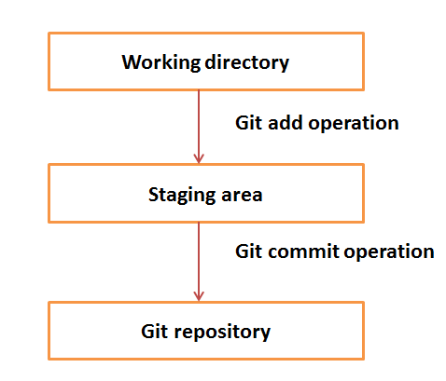

**Create repository**:

* Git init <repo name>

Or

* Mkdir <folder name> go to that folder and git init
* Git add files
* Git commit –m”message” (SHA1)

**Head**: which always points to the latest commit in the branch

$ ls -1 .git/refs/heads/

$ cat .git/config

[ubuntu ~]$ sudo apt-get install git-core (OR) apt-get install git* -y

[CentOS ~]# yum -y install git-core (OR) yum install git* -y

# git –version (To check git version)

### **Setting username**

$ git config --global user.name "venky"

**Setting email id**

$git config --global user.email "venky@gmail.com"

**$ git config –list**

### **Color highlighting**

[jerry@CentOS project]$ git config --global color.ui true

[jerry@CentOS project]$ git config --global color.status auto

[jerry@CentOS project]$ git config --global color.branch auto

**General workflow:**

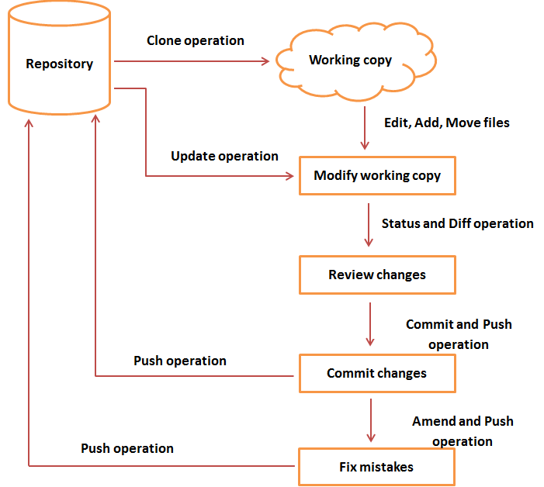

## Create New User

# add new group

[root@CentOS ~]# groupadd dev

# add new user

[root@CentOS ~]# useradd -G devs -d /home/gituser -m -s /bin/bash gituser

# change password

[root@CentOS ~]# passwd gituser